**Report on DBMS Project**

**The Telecommunication Management System**

Tables :

Employee:

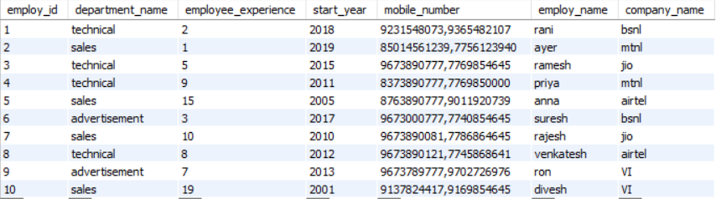

Customer-Service:

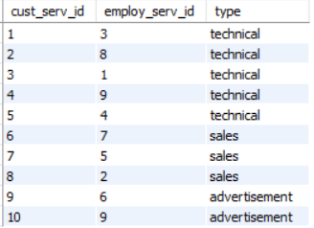

Company:

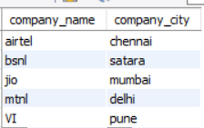

Customer:

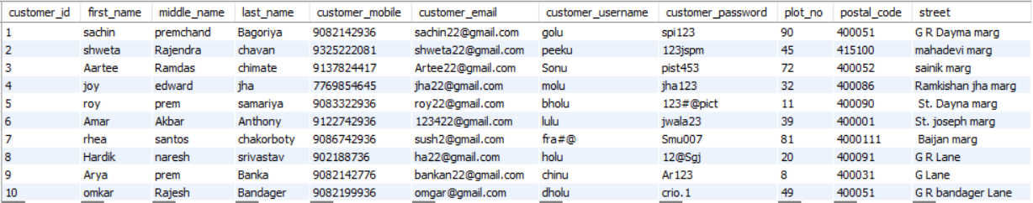

Bill:

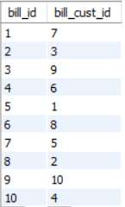

Payment:

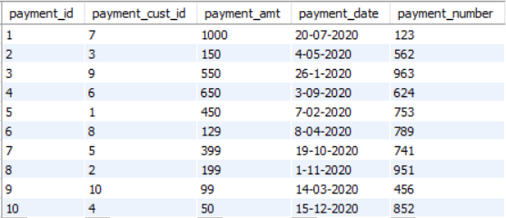

Network-Connection:

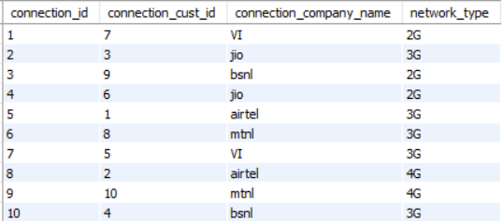

Hardware-Connection:

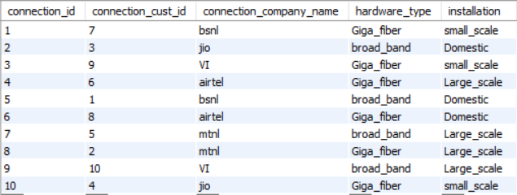

Post-paid Account:

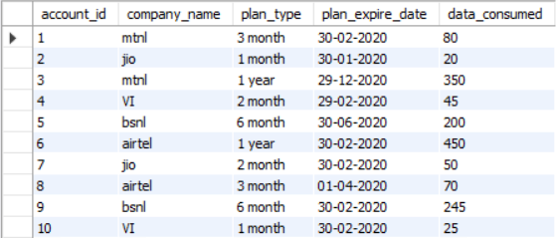

Pre-Paid Account:

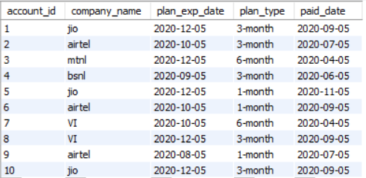

**Queries:**

**[Query .1]** Find the pre-paid account details of customer whose username is fra#@ .

**Solution:**

select account_id,company_name,plan_type,plan_exp_date,paid_date

from prepaid_account,customer

where account_id = customer_id and customer_username ='fra#@';

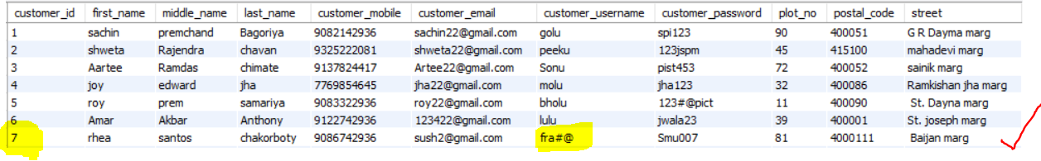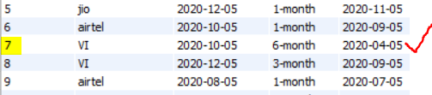

**Output:**



**[Query .2]** Display the details of customer whose customer id=9

**Solution:**

select * from customer

where customer_id=9;

**Output:**

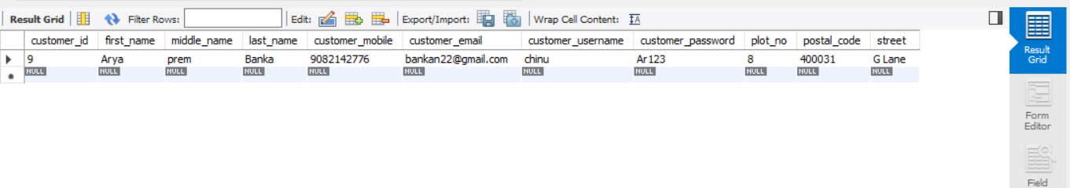

**[Query .3]** Create a view of customer that have airtel connection and display there hardware connection details.

**Solution:**

create view airtel_user AS

select first_name,middle_name,last_name,customer_username,connection_company_name,hardware_type,installation

from customer,hardware_connection

where customer_id=connection_cust_id and connection_company_name='airtel';

select * from airtel_user;

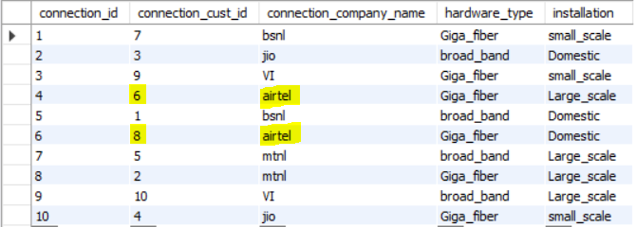

**Output:**

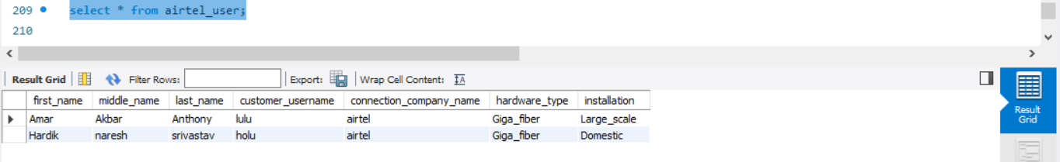

**[Query .4]** Display the details of Employee that has the highest experience.

**Solution:**

Select employ_id,employ_name,company_name,department_name,start_year,mobile_number

from Employee

where employee_experience= (select max(employee_experience) from Employee)

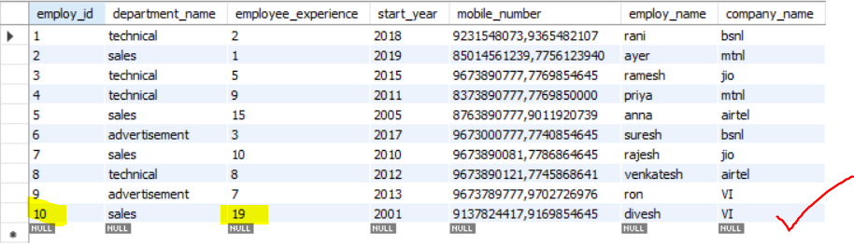

**Output:**

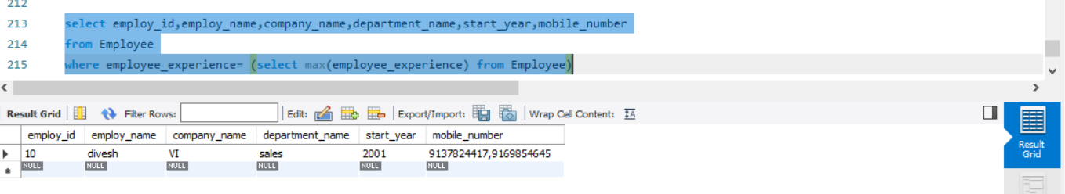

**[Query .5]** Display payment details of customer whose mobile number is 902188736.

**Solution:**

select payment_cust_id,payment_amt,payment_date,payment_number

from payment,customer

where payment_cust_id=customer_id and customer_mobile='902188736';

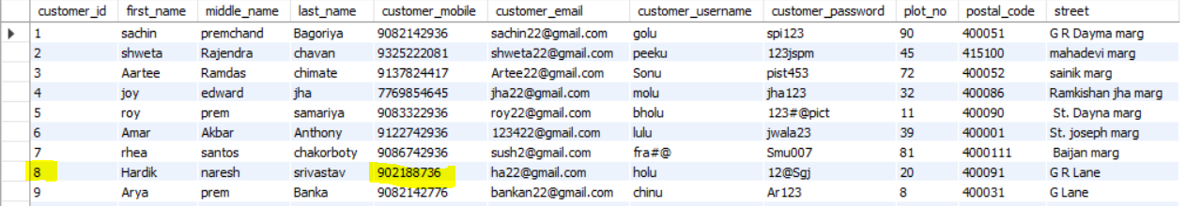

**Output:**



**[Query .6]** before deleting any record form company table.

**Solution:**

Create or replace trigger remove_name

Before delete On company

For each row

Begin

DBMS_OUTPUT.PUT_LINE('Are u want to remove the name from company ');

End;

Delete from company

where company_name='VI'

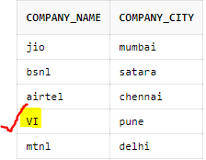

**Output:**

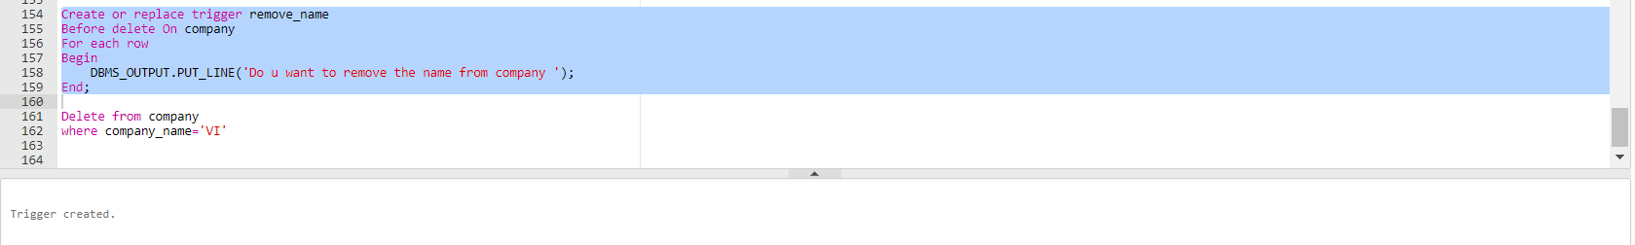



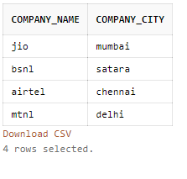

As seen from the company table company name VI (record) has been deleted.

**[Query .7]** after update on payment table

**Solution:**

Create or replace trigger pay_check

after update

On payment

For each row

When(new.payment_amt=1000)

Begin

DBMS_OUTPUT.PUT_LINE('sucessfull');

End;

Update payment

set payment_amt=1000

where payment_cust_id=2;

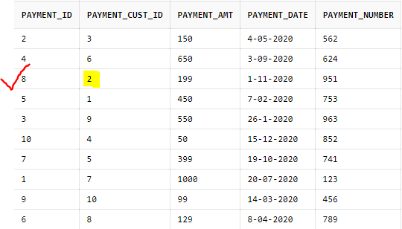

**Output:**

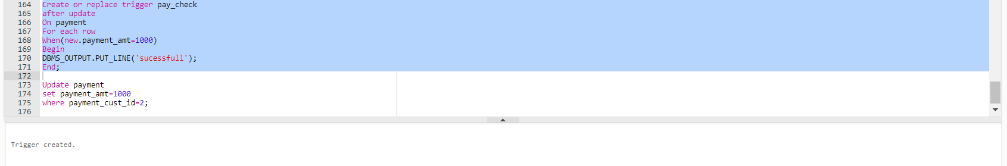



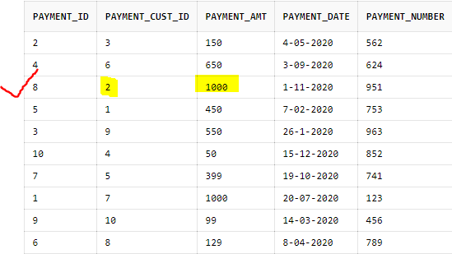

As observed the payment amount is updated to 1000 from 199.

**[Query .8]** After insert on bill table.

**Solution:**

Create or replace trigger insert_succesfully

After insert

On bill

For each row

Begin

DBMS_OUTPUT.PUT_LINE( 'bill_id added successfully to bill');

end;

Insert into bill

values (11,8);

**Output:**

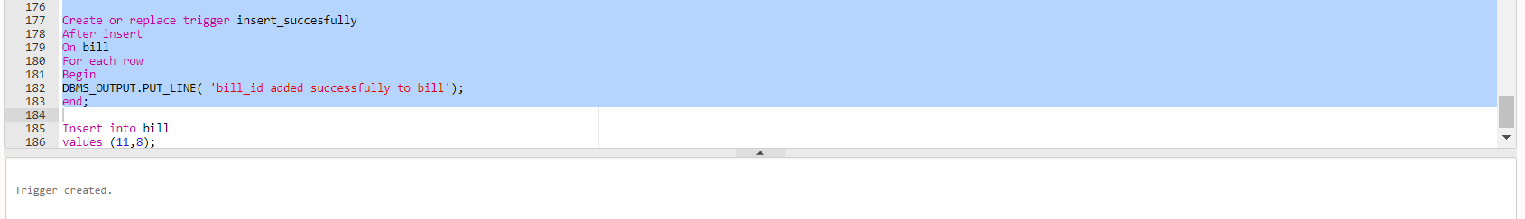



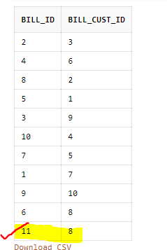

As Observed (11,8) is inserted.

**[Query .9]** Display all the customer who consume more than 100 GB data in postpaid account.

**Solution:**

select * from customer where customer_id in (select account_id from post_paid_account where data_consumed>100);

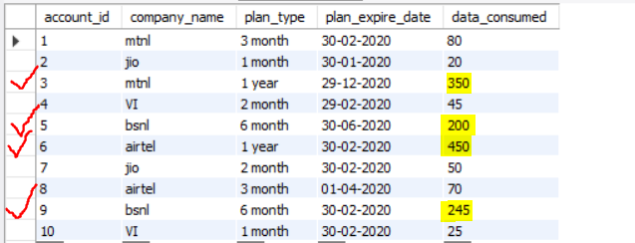

**Output:**

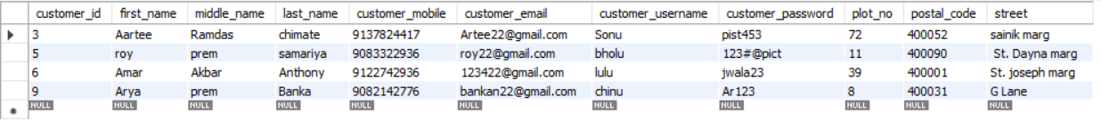

**[Query .10]** Display the customer details seeking customer-service from Employee who works in technical department.

**Solution:**

select * from customer where customer_id in (select cust_serv_id from cust_service where type='technical');

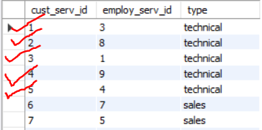

**Output:**

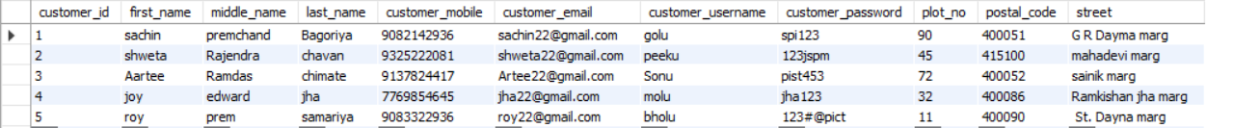

**[Query .11]** Write a query to display all the employee for the company who belong to the city='mumbai'?

**Solution:**

select * from employee where company_name in (select company_name from company where company_city='mumbai')

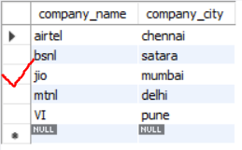

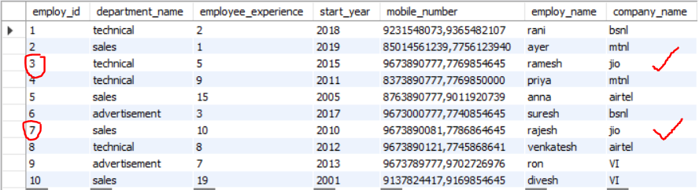

**Output:**



**[Query .12]** Create a customer view table and perform insert, delete and update operations.

**Solution:**

create view customer_view_table as

select customer_id,first_name,middle_name,last_name,customer_mobile,customer_email,customer_username,customer_password,plot_no,postal_code,street

from customer;

select * from customer_view_table;

**Output:**

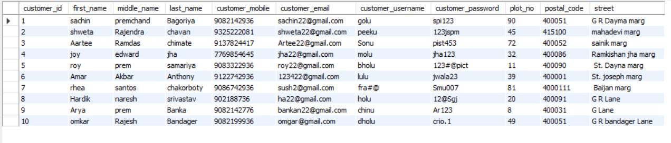

insert into customer_view_table(customer_id,first_name,middle_name,last_name,customer_mobile,customer_email,customer_username,customer_password,plot_no,postal_code,street)

values (11,'avinash','ramdas','chimate',8779012345,'avichimate@gmail.com','avi123','dadu',51,400004,'m.j marg');

**Output:**

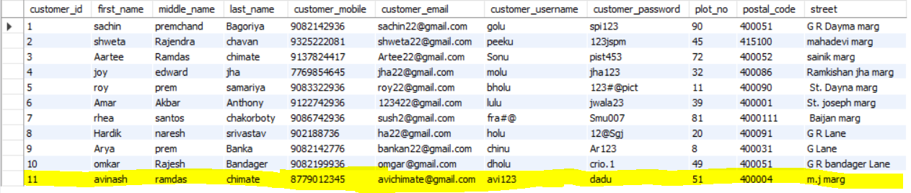

delete from customer_view_table where customer_id=5;

**Output:**

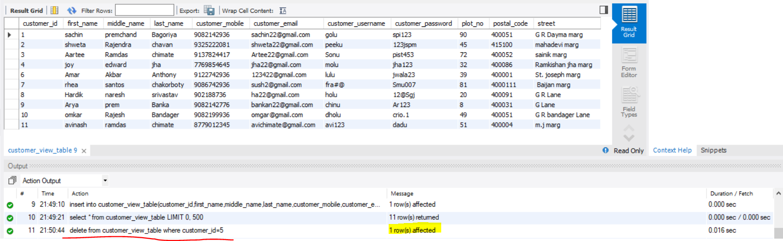

No record with customer-id = 5 is present.

update customer_view_table set customer_username='babu' where street='G R Lane';

**Output:**

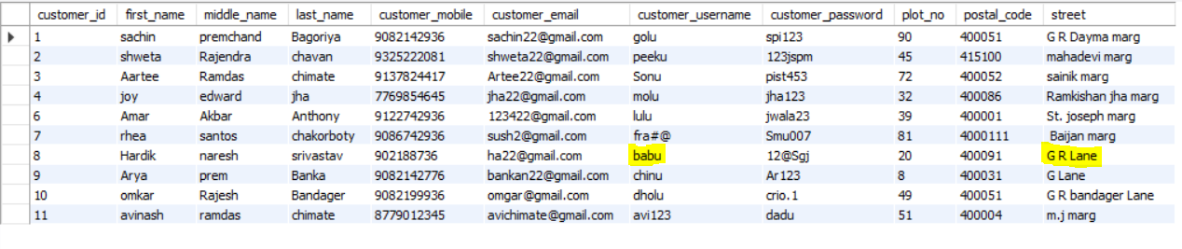

Customer-username is changed to babu from holu where street is G R Lane.

\*\*\*\*\*\*\*\*\*\*\*\*\*\*\*\*\*\*\****Thank You!!!*** *****************